SOWIT Video Series – “Gratitude is the Sign of Noble Souls”
(Video link: www.edb.gov.hk/sowit_noble)

Lesson Plan
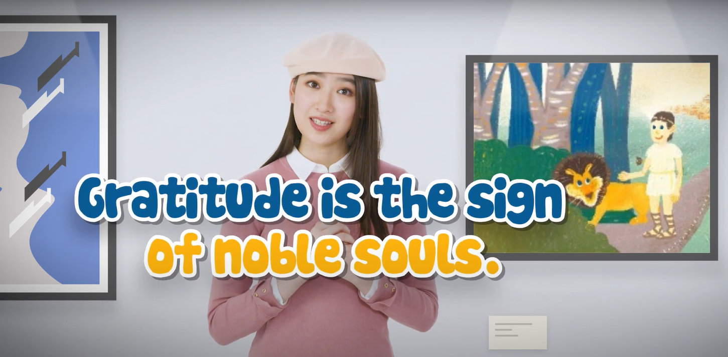

Suggested Levels
Upper Primary/Junior Secondary
Summary of the Learning Task
Students watch the SOWIT video “Gratitude is the Sign of Noble Souls”, which is about a slave helping a lion when it was in trouble. In return, the lion showed gratitude to the slave by saving his life. Students are then guided to understand the meaning of the saying “Gratitude is the sign of noble souls”, learn about the related positive values and attitudes (e.g. be grateful, be empathetic, care for others), and write a thank-you card to someone whom students would like to show appreciation to.
Learning Objectives
Content
- To understand the meaning of the saying “Gratitude is the sign of noble souls.” through a story presented in the context of a video
Language
- To explore the story elements of the video (e.g. setting, problem, solution, suspense, twist, main characters, supporting characters)
- To describe the appearance, feelings and personality of the main characters by using a range of adjectives
Values and Attitudes
- To cultivate positive values and attitudes (e.g. be grateful, be empathetic, care for others)

Sharing Learning Intentions
- Introduce the objectives of the learning activities
Pre-viewing
Part A: Making Predictions about the Story Elements
- Refer students to Activity Sheet: Part A.
- Draw students’ attention to the picture below, which depicts the main characters and a scene of the SOWIT video “Gratitude is the Sign of Noble Souls”. Invite them to make predictions about what the story is about.
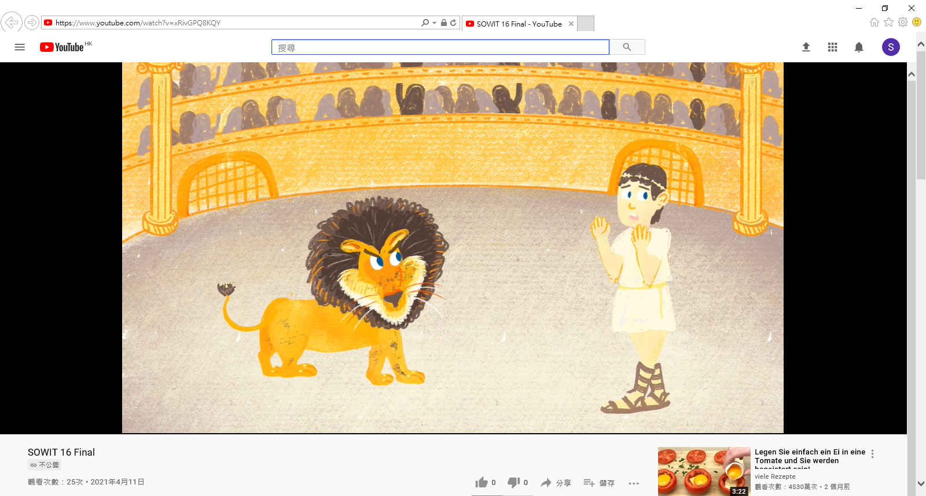
- Discuss with students their observations about the setting, the feelings of the characters and the plot.
- After playing the video, have students check whether their predictions are correct.
Viewing
Part B: Understanding the Story Elements
- Refer students to Activity Sheet: Part B.
- Introduce the story elements (e.g. setting, problem, solution, suspense, twist) before playing the video and instruct students to note down some key points for each element while watching the video.
- Play the video “Gratitude is the Sign of Noble Souls”.
- Discuss with students the story elements of the video.

Post-viewing
Part C: Understanding the Characters
- Refer students to Activity Sheet: Part C.
- Instruct students to identify the main and supporting characters.
- Guide students to analyse the main characters (i.e. Androcles and the lion) using the “Role on the Wall”:
  - Elicit from students the adjectives describing the appearance, feelings and personality of Androcles and the lion at different stages of the story; and
  - Invite them to substantiate the choice of adjectives with relevant examples.
- Instruct students to identify other characters’ perception of the main characters. Draw students’ attention to the change in the perception as the story unfolds.
- Play the video again whenever necessary.
Part D: Understanding the Theme and the Saying of Wisdom
- Refer students to Activity Sheet: Part D.
- Guide students to work out the meaning of the saying (i.e. people who show gratitude to others are blessed souls) by revisiting the lion’s good deeds done in return for Androcles’s kindness.
- Discuss with students the messages conveyed (i.e. be grateful and show appreciation to those who are kind to us; be empathetic and offer a helping hand to those in need) in the story.
- Invite students to recall the good deeds people have done for them.
- Instruct students to write a thank-you card to someone whom they would like to show appreciation to. In the thank-you card, students should include:
  - The good deeds someone performed and their gratitude;
  - How they could pay it forward; and
  - The saying of wisdom “Gratitude is the sign of noble souls”.

SOWIT Video Series - “Gratitude is the Sign of Noble Souls”
Activity Sheets

(Pre-viewing)

Part A: Making Predictions about the Story Elements
- The picture below depicts a scene of the SOWIT video “Gratitude is the Sign of Noble Souls”. What do you think the story is about? Answer the questions in Boxes (a) – (c).

(Viewing)

Part B: Understanding the Story Elements
- Look at the pictures below. They depict several scenes of the video. Complete the table below to learn more about the development of the story.
Problem
Suspense
Problem
Solution
Solution
- Setting: In the forest
- Who was Androcles? Why did he run away? How did he feel?
_________________________________
_________________________________
_________________________________
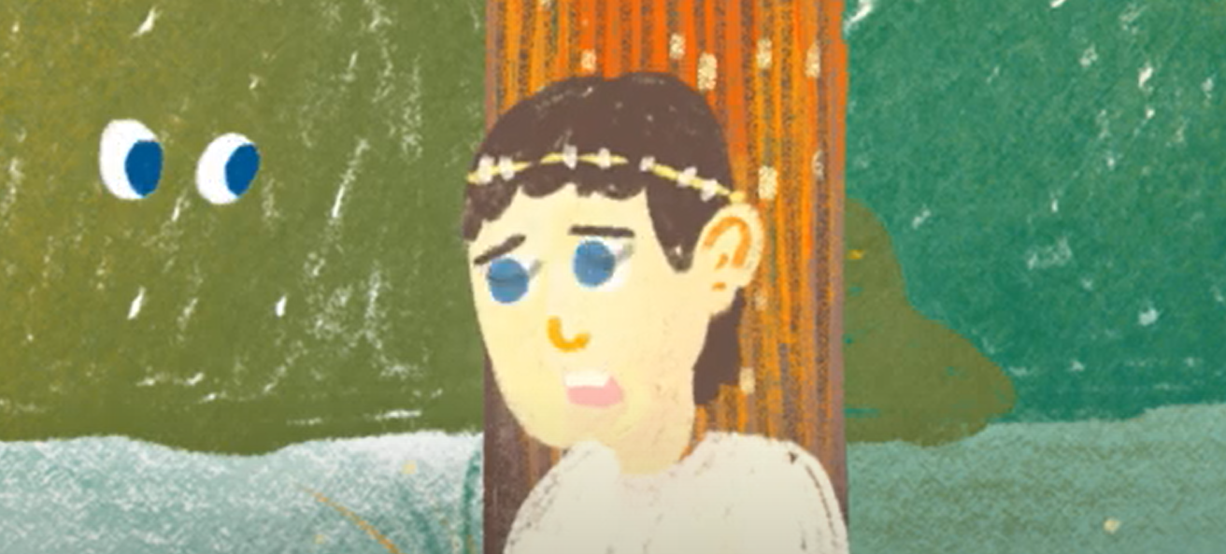 | “Little did he know that some (b) _________________________ was waiting for him.”  - What was the mood of this scene?  _________________________________
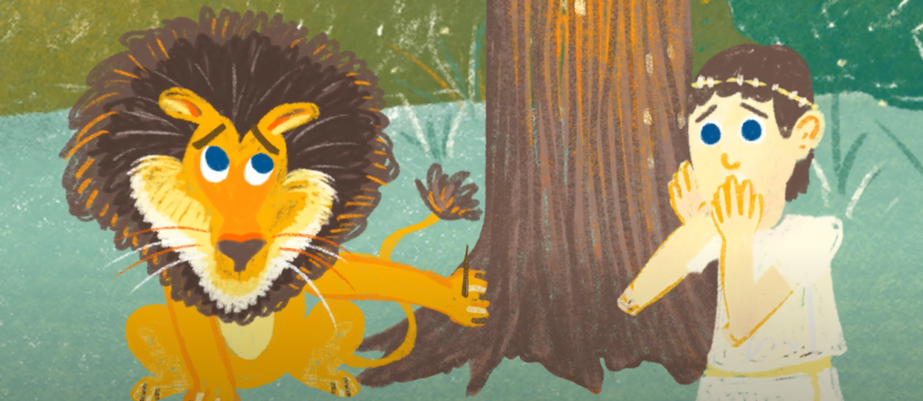 | - What problem did the lion encounter?  _________________________________  _________________________________
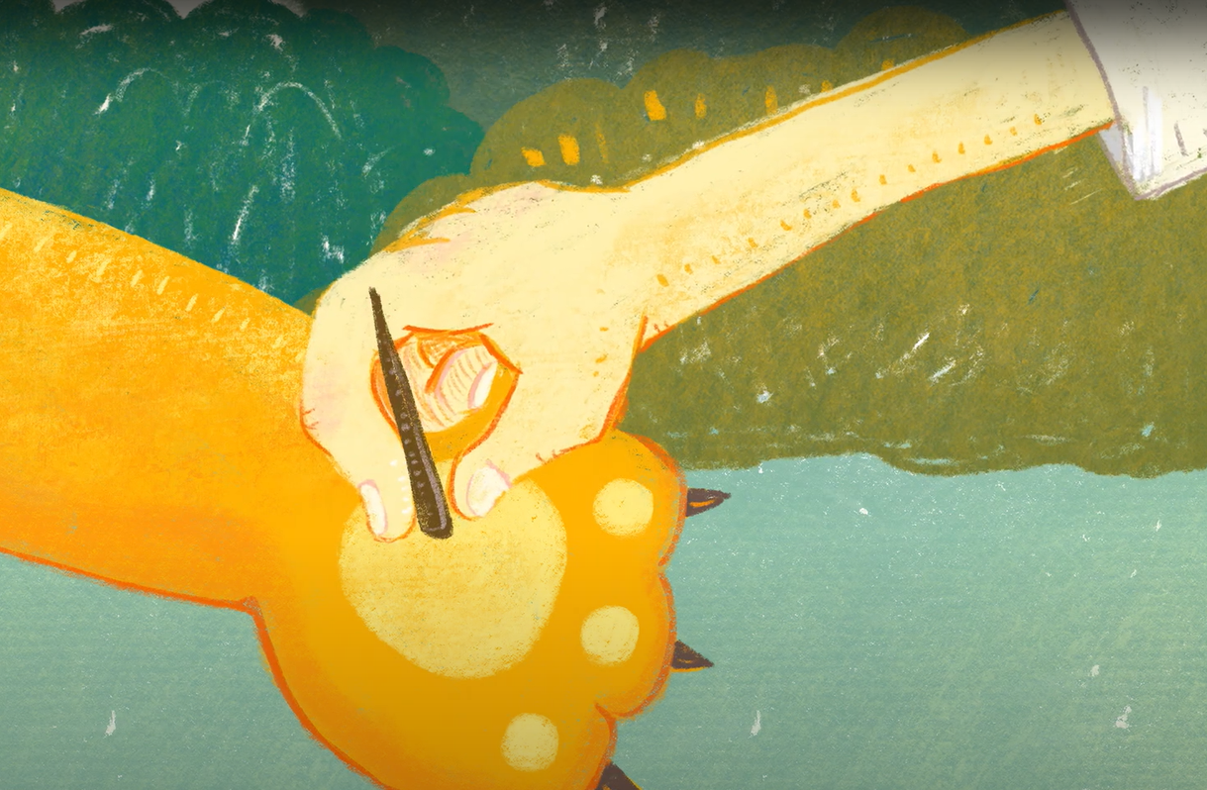 | - How was the lion’s problem solved?  _________________________________  _________________________________
- How was Androcles’s problem solved?
_________________________________
_________________________________
_________________________________
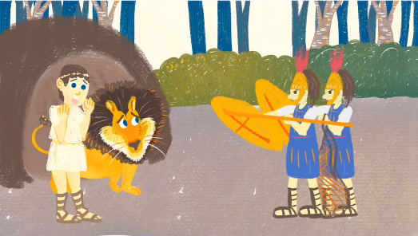 | - What happened to Androcles and the lion?  _____________________________________  _____________________________________
- Setting: At the Colosseum
- What problem did the lion encounter?
_____________________________________
_____________________________________

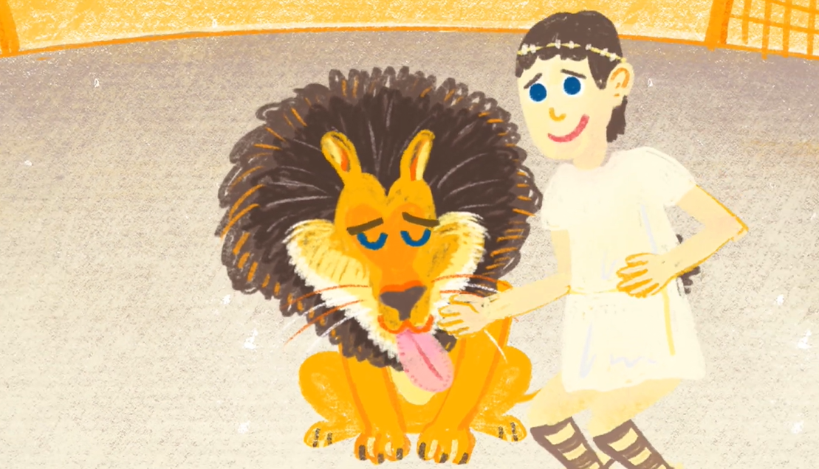 | - What did the lion do when he saw Androcles at the colosseum?  _____________________________________  _____________________________________  (j) What reaction did you originally expect from the lion?  _____________________________________  _____________________________________  (k) How did you feel when you saw the lion’s reaction?  _____________________________________
- What happened to Androcles and the lion in the end?
_____________________________________
_____________________________________
Solution
Twist
Problem
Problem
(Post-viewing)
Part C: Understanding the Characters
  - Who are the main characters and the supporting characters in the story?
Main characters:
Supporting characters:

  - Complete the following “Role on the Wall” to gain a better understanding of the main characters.
(I) Role on the Wall – Androcles
(b) His feelings:
(i) In the forest:
______________________
(ii) Reason: ______________________
______________________
(iii) At the colosseum:
______________________
(iv) Reason: ______________________
______________________
- His clothing:
Simple/extravagant*
(*delete as appropriate)

(c) His personality:
(i) In the forest:
____________________ (ii) Evidence:
____________________
____________________
____________________
(iii) At the colosseum:
________________________________________ (iv) Evidence:
____________________
____________________
____________________

(d) Other characters’ perception of Androcles:
(i) The lion: _______________________________
(ii) Reason: _______________________________
_________________________________________.
(iii) The soldiers in the forest:_________________
(iv) Reason: _______________________________
_________________________________________.
The emperor:
- At the beginning, he thought Androcles was (v) ______________ as (vi) ________________ _____________________________________.
- In the end, he thought Androcles was (vii) ________________ as (viii) _____________ _____________________________________.

- Role on the Wall – The Lion
- His appearance:
At the colosseum:
fierce
(c) His personality:
(i) In the forest:
________________________
(ii) Evidence:
________________________
________________________
________________________
(iii) At the colosseum:
________________________________________________
(iv) Evidence:
________________________
________________________

(b) His feelings:
(i) In the forest:
______________________
(ii) Reason: ______________________
______________________
(iii) At the colosseum:
______________________
(iv) Reason: ______________________
______________________

(d) Others characters’ perception of the lion:
The emperor:
- At the beginning, he thought the lion was (i) ______________ as
(ii) _________________________________________________.
- In the end, he thought the lion was (iii) __________________ as
(iv) ________________________________________________.
The audience at the colosseum:
(v)____________________________________________________
Androcles:
- At the beginning, he thought the lion was (vi) ______________ as (vii) _________________________________________________.
- In the end, he thought Androcles was (viii) ________________ as (ix) __________________________________________________.

Part D: Understanding the Saying of Wisdom
- Look at the pictures and complete the diagram below to illustrate how the lion showed gratitude for Androcles’s kindness.
The lion’s good deeds
(b) What did the lion do in the forest?

______________________________________________________
Androcles’s good deed
- What did Androcles do?

______________________________________________________

“Gratitude is the sign of noble souls.”

(d) What is the meaning of the saying?
______________________________________________________

(c) What did the lion do at the colosseum?

______________________________________________________

- What is the message conveyed in the story?
______________________________________________________________________________________________________________________________________________

- Write a thank-you card to someone whom you would like to show appreciation to. Express your gratitude for the good deeds that he/she has done to you and how you could pay it forward. Don’t forget to include the saying of wisdom “Gratitude is the sign of noble souls.” in the thank-you card.

Dear ______________________,

______________________________________________________________________
______________________________________________________________________
______________________________________________________________________
______________________________________________________________________
______________________________________________________________________
______________________________________________________________________
______________________________________________________________________
______________________________________________________________________
______________________________________________________________________
______________________________________________________________________
______________________________________________________________________
______________________________________________________________________
______________________________________________________________________

________________________________ ,
_________________________

SOWIT Video Series – “Gratitude is the Sign of Noble Souls”
Activity Sheets (Suggested Answers)

Part A: Making Predictions about the Story Elements
      - At the Colosseum (Accept any reasonable answers.)
      - The lion: angry; The man: scared/worried (Accept any reasonable answers.)
      - Accept any reasonable answers.

Part B: Understanding the Story Elements
- He was a slave and he ran into the forest to avoid being captured by the soldiers.
He was cold and hungry.
- “Little did he know that some unexpected company was waiting for him.”
- Mysterious/Scary/Tensed (Accept any reasonable answers.)
- He got a splinter in his palm.
- Androcles removed the splinter for him.
- The lion took Androcles to his cave and gave him some food.
- They were captured by the soldiers.
- He was starved for days in a cage.
- He licked Androcles’s hand like a puppy.
- Accept any reasonable answers.
- Astonished/ Surprised/Amazed/Touched (Accept any reasonable answers.)
- They were released and regained their freedom at last.

Part C: Understanding the Characters
- Main characters: Androcles, the lion
Supporting characters: The emperor, the soldiers
- (I) Role on the Wall – Androcles
- His clothing: Simple
- His feelings:
  - Worried
  - Worried about being captured by the soldiers and/or killed by the lion
  - Scared
  - Scared of being attacked by the lion
- His personality:
  - Compassionate/helpful/kind-hearted/empathetic
  - He helped the lion to remove the splinter despite being chased by the soldiers.
  - Brave/courageous
  - He bravely faced the lion without escaping.
- Others characters’ perception of Androcles:
  - Helpful
  - Androcles removed the splinter in his palm.
  - Weak/fragile/insignificant
  - He was a slave to be captured.
The emperor
    - At the beginning, he thought Androcles was (v) weak/fragile/insignificant as (vi) he was just a slave and a prey of the lion.
    - In the end, he thought Androcles was (vii) kind/noble as (viii) he helped the lion in the forest.

      - Role on the Wall – The Lion
- His appearance
At the Colosseum: Fierce (given)
- His feelings:
  - Grateful
  - Androcles helped him remove the splinter.
  - Starving
  - He was starved for days in a cage.
- His personality:
  - Helpful/generous/compassionate/thankful/grateful
  - He took Androcles to his cave and gave him some food.
  - Grateful/loyal
  - He did not attack Androcles and showed his gratitude by licking Androcles’s hand instead.
- Others characters’ perception of him:
The emperor
- At the beginning, he thought the lion was (i) cruel as (ii) the lion was the predator and would attack Androcles for meal.
- In the end, he thought the lion was (iii) noble as (iv) he did not attack Androcles to repay Androcles for his kindness.
The audience at the colosseum
  - Cruel
Androcles:
- At the beginning, he thought the lion was (vi) fierce/cruel as (vii) he believed the lion was a predator and would kill him for food.
- In the end, he thought the lion was (viii) kind/grateful/loyal as (ix) the lion did not attack him in return for his good deed done before.

Part D: Understanding the Saying of Wisdom
      - (a) He removed the splinter from the lion’s palm.
(b) He took Androcles to his cave and gave him some food.
(c) He did not attack Androcles and licked his hand like a puppy.
(d) People who show gratitude to others are blessed souls.
2. We should be grateful and show appreciation to the good deeds people do to us. We should also be empathetic/compassionate and show concern to the people around us and lend a helping hand to those in need.
3. Accept any reasonable answers.

